| **Test Name** | | Add Worker to System | | | |
| --- | --- | --- | --- | --- | --- |
| **Use Case Tested:** | | Use Case 9 – Manage Worker | | | |
| **Test Description:** | | User needs to add a new worker  User navigates to Manage Workers tab.  User is presented with a blank form to add the new worker details.  User enters the required information  User submits form | | | |
| **Pre-conditions** | | Worker must not exist in the system | | | |
| **Post-conditions** | | The database is successfully updated with the new data for the Worker. | | | |
| **Notes:** | |  | | | |
| **Result (Pass/Fail/Warning/Incomplete)** | |  | | | |
|  | **TEST STEP** | | **EXPECTED TEST RESULTS** | P | F |
|  | User selects “Manage Workers” from the menu bar | | A blank Worker Details form appears | X |  |
|  | User enters the Worker’s Id | | Input does not show error | X |  |
|  | User enters the Worker’s First Name | | Input does not show error | X |  |
|  | User enters the Worker’s Surname | | Input does not show error | X |  |
|  | User enters the Worker’s Position | | Input does not show error | X |  |
|  | User selects whether the Worker is active or not | | Input is accepted | X |  |
|  | User selects Submit button | | Message appears that the record was successfully added | X |  |
|  |  | | Database updated to show new worker & related details | X |  |

|  |  |  |  |  |  |
| --- | --- | --- | --- | --- | --- |
| **Test Data Table** | | | | | |
|  | **1** | **2** | **3** | **4** | **5** |
| Test – 1 | 9123 | Frank | Gravel | Pharmacist | Yes |
| Test – |  |  |  |  |  |
| Test – |  |  |  |  |  |
|  |  |  |  |  |  |

Worker Details Form

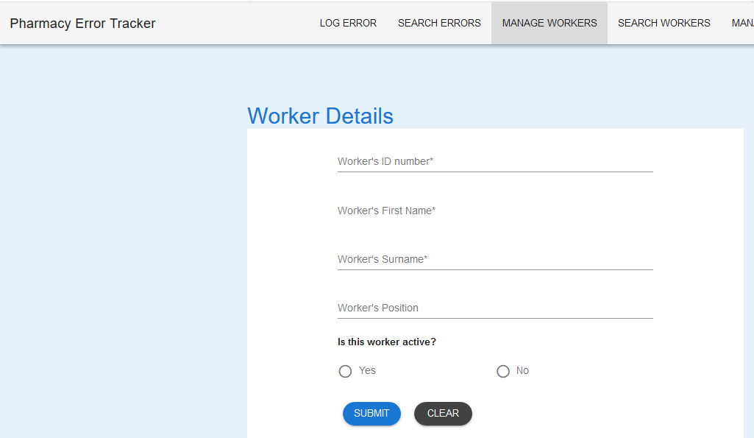

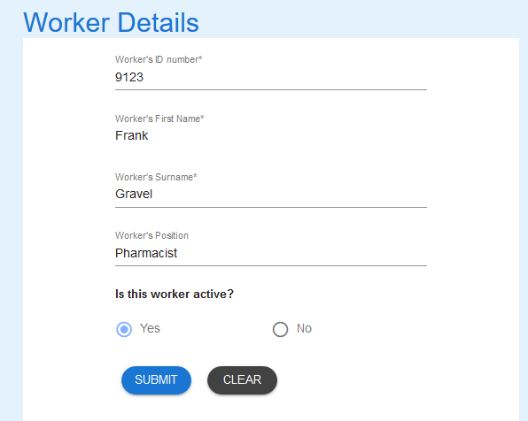

Worker details entered



Worker added – Worker details in database

